Problem Statement:

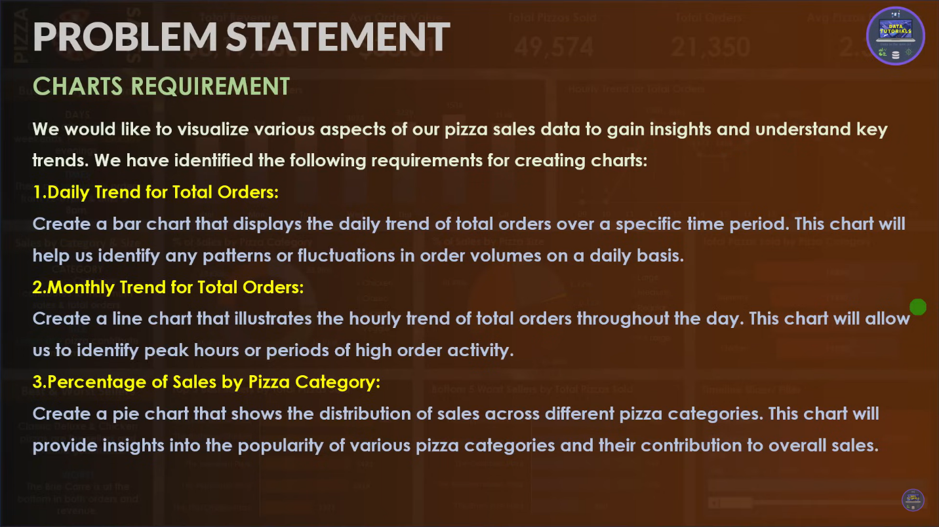

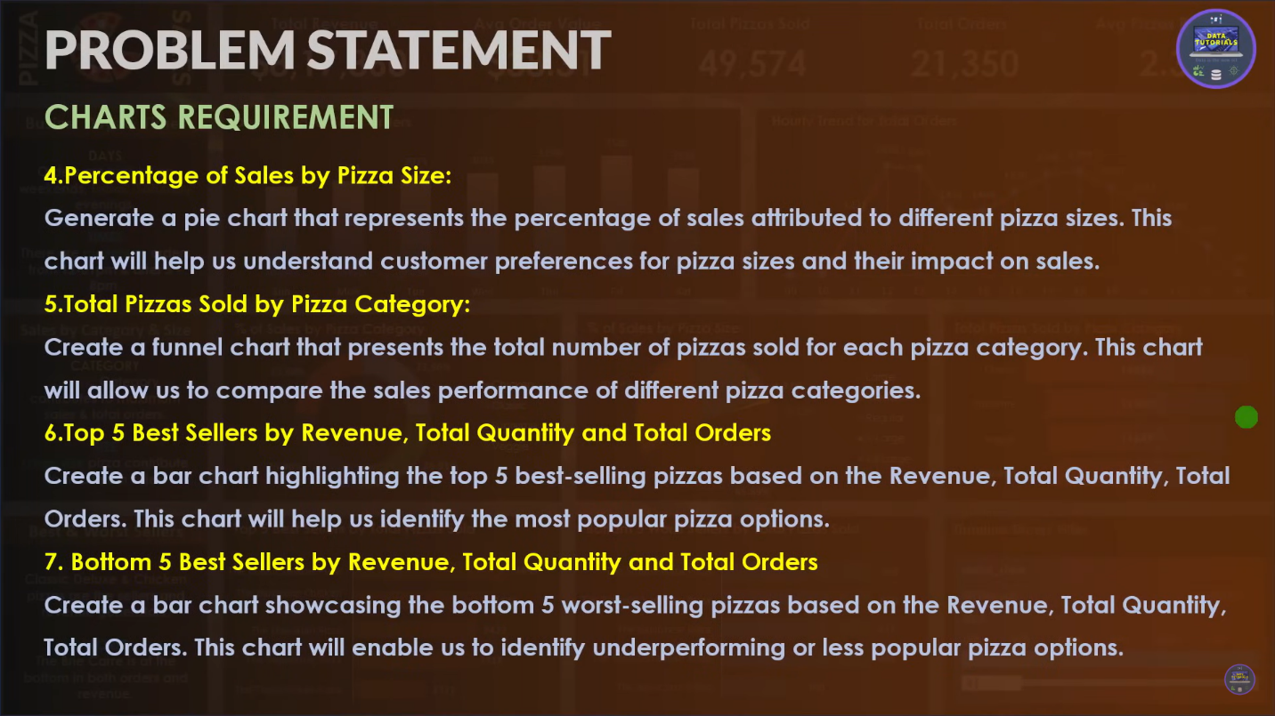

**Q1. Total Revenue:**

Select sum(total_price) as Total_Revenue

From pizza_sales

Output:

**Q2. Average Order Value**

Select Sum(total_price) / Count(Distinct order_id) as Avg_order_value from pizza_sales

Output:

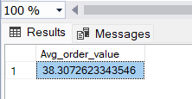

**Q3. Total Pizzas Sold**

Select sum(quantity) as Total_Pizzas_Sold from pizza_sales

Output:

**Q4. Total Orders**

Select Count(Distinct order_id) as Total_Orders from pizza_sales

Output:

**Q5. Average Pizzas per order**

Select cast(cast(sum(quantity) as decimal(10,2))/

cast(count(distinct order_id) as decimal(10,2) ) as decimal(10,2)) as Average_Pizzas_Per_order from pizza_sales

Output:

Charts

Q1. **Daily Trend for Total Orders**

Select datename(Dw,order_date) as Order_day , Count(distinct order_id) as Total_Orders

from pizza_sales

group by(datename(Dw,order_date))

Output:

Q2. **Monthly Trend for Orders**

Select datename(MONTH,order_date) as Month_name , Count(distinct order_id) as Total_Orders

from pizza_sales

group by(datename(MONTH,order_date))

order by Total_Orders desc

Output:

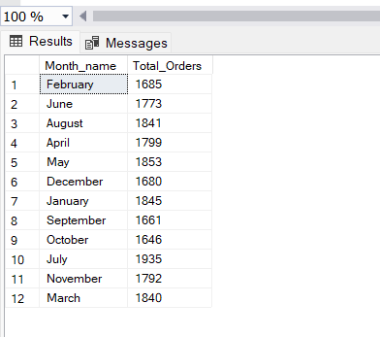

Q3. **% of Sales by Pizza Category**

Select pizza_category , sum(total_price) as Total_Sales , sum(total_price)*100/

(Select sum(total_price) from pizza_sales) as PCT

from pizza_sales

group by pizza_category

Output:

Note:

For individual months sales percentage

Select pizza_category , sum(total_price) as Total_Sales , sum(total_price)*100/

(Select sum(total_price) from pizza_sales where month(order_date) = 1) as PCT

from pizza_sales

where month(order_date) = 1

group by pizza_category

Q4. **% of Sales by Pizza Size**

Select pizza_size , sum(total_price) as Total_Sales , sum(total_price)*100/

(Select sum(total_price) from pizza_sales ) as PCT

from pizza_sales

group by pizza_size

order by PCT desc

Output:

Q5. **Top 5 Pizzas by Revenue**

Select Top 5 pizza_name , sum(total_price) as Total_Revenue from pizza_sales

group by pizza_name

order by Total_Revenue Desc

output:

Q6. **Bottom 5 Pizzas by Revenue**

Select Top 5 pizza_name , sum(total_price) as Total_Revenue from pizza_sales

group by pizza_name

order by Total_Revenue Asc

output:

Q7. **Top 5 Pizzas by Quantity**

Select Top 5 pizza_name, SUM(quantity) AS Total_Pizza_Sold

From pizza_sales

Group By pizza_name

Order By Total_Pizza_Sold DESC

Output:

Q8. **Bottom 5 Pizzas by Quantity**

Select Top 5 pizza_name, SUM(quantity) AS Total_Pizza_Sold

From pizza_sales

Group By pizza_name

Order By Total_Pizza_Sold ASC

Output:

Q9. **Top 5 Pizzas by Total Orders**

Select Top 5 pizza_name, COUNT(Distinct order_id) AS Total_Orders

From pizza_sales

Group By pizza_name

Order By Total_Orders DESC

Output:

Q10.**Borrom 5 Pizzas by Total Orders**

Select Top 5 pizza_name, COUNT(Distinct order_id) As Total_Orders

From pizza_sales

Group By pizza_name

Order By Total_Orders Asc

Output:

